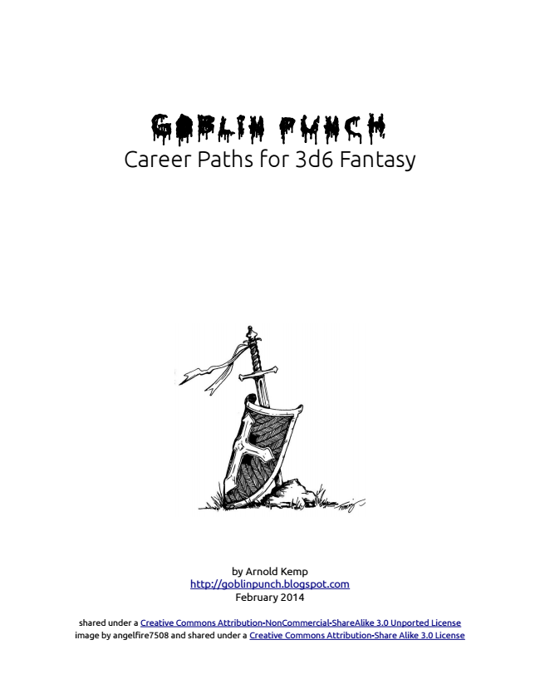
GOBLIN PUNCH Career Paths for 3d6 Fantasy
by Arnold Kemp http://goblinpunch.blogspot.com February 2014
shared under a Creative Commons Attribution-NonCommercial-ShareAlike 3.0 Unported License image by angelfire7508 and shared under a Creative Commons Attribution-Share Alike 3.0 License
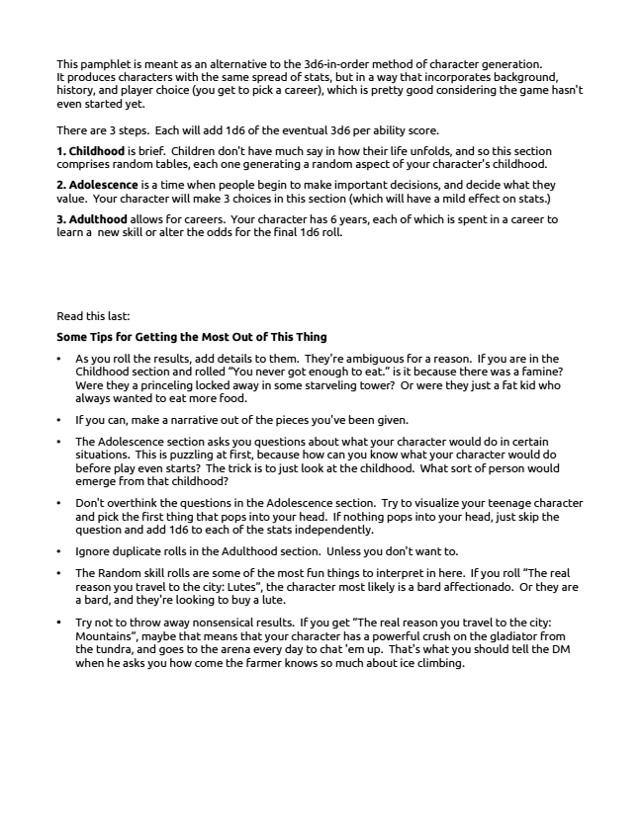
This pamphlet is meant as an alternative to the 3d6-in-order method of character generation. It produces characters with the same spread of stats, but in a way that incorporates background, history, and player choice (you get to pick a career), which is pretty good considering the game hasn't even started yet.
There are 3 steps. Each will add 1d6 of the eventual 3d6 per ability score.
1. Childhood is brief. Children don't have much say in how their life unfolds, and so this section comprises random tables, each one generating a random aspect of your character's childhood.
2. Adolescence is a time when people begin to make important decisions, and decide what they value. Your character will make 3 choices in this section (which will have a mild effect on stats.)
3. Adulthood allows for careers. Your character has 6 years, each of which is spent in a career to learn a new skill or alter the odds for the final 1d6 roll.
Read this last:
Some Tips for Getting the Most Out of This Thing
• As you roll the results, add details to them. They're ambiguous for a reason. If you are in the Childhood section and rolled “You never got enough to eat.” is it because there was a famine? Were they a princeling locked away in some starveling tower? Or were they just a fat kid who always wanted to eat more food.
• If you can, make a narrative out of the pieces you've been given.
• The Adolescence section asks you questions about what your character would do in certain situations. This is puzzling at first, because how can you know what your character would do before play even starts? The trick is to just look at the childhood. What sort of person would emerge from that childhood?
• Don't overthink the questions in the Adolescence section. Try to visualize your teenage character and pick the first thing that pops into your head. If nothing pops into your head, just skip the question and add 1d6 to each of the stats independently.
• Ignore duplicate rolls in the Adulthood section. Unless you don't want to.
• The Random skill rolls are some of the most fun things to interpret in here. If you roll “The real reason you travel to the city: Lutes”, the character most likely is a bard affectionado. Or they are a bard, and they're looking to buy a lute.
• Try not to throw away nonsensical results. If you get “The real reason you travel to the city: Mountains”, maybe that means that your character has a powerful crush on the gladiator from the tundra, and goes to the arena every day to chat 'em up. That's what you should tell the DM when he asks you how come the farmer knows so much about ice climbing.
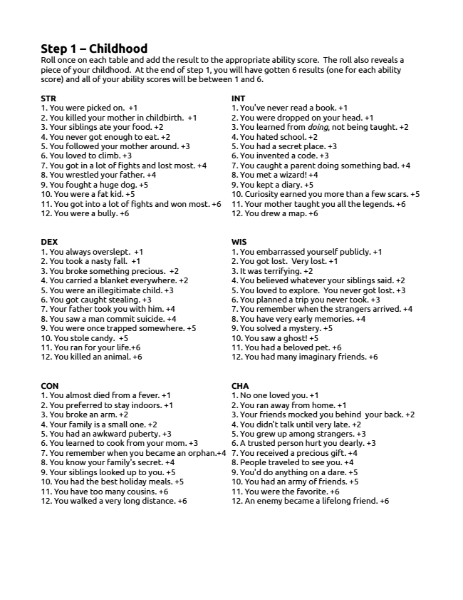
Step 1 – Childhood Roll once on each table and add the result to the appropriate ability score. The roll also reveals a piece of your childhood. At the end of step 1, you will have gotten 6 results (one for each ability score) and all of your ability scores will be between 1 and 6.
STR 1. You were picked on. +1 2. You killed your mother in childbirth. +1 3. Your siblings ate your food. +2 4. You never got enough to eat. +2 5. You followed your mother around. +3 6. You loved to climb. +3 7. You got in a lot of fights and lost most. +4 8. You wrestled your father. +4 9. You fought a huge dog. +5 10. You were a fat kid. +5 11. You got into a lot of fights and won most. +6 12. You were a bully. +6
DEX 1. You always overslept. +1 2. You took a nasty fall. +1 3. You broke something precious. +2 4. You carried a blanket everywhere. +2 5. You were an illegitimate child. +3 6. You got caught stealing. +3 7. Your father took you with him. +4 8. You saw a man commit suicide. +4 9. You were once trapped somewhere. +5 10. You stole candy. +5 11. You ran for your life.+6 12. You killed an animal. +6
CON 1. You almost died from a fever. +1 2. You preferred to stay indoors. +1 3. You broke an arm. +2 4. Your family is a small one. +2 5. You had an awkward puberty. +3 6. You learned to cook from your mom. +3 7. You remember when you became an orphan.+4 8. You know your family's secret. +4 9. Your siblings looked up to you. +5 10. You had the best holiday meals. +5 11. You have too many cousins. +6 12. You walked a very long distance. +6
INT 1. You've never read a book. +1 2. You were dropped on your head. +1 3. You learned from doing, not being taught. +2 4. You hated school. +2 5. You had a secret place. +3 6. You invented a code. +3 7. You caught a parent doing something bad. +4 8. You met a wizard! +4 9. You kept a diary. +5 10. Curiosity earned you more than a few scars. +5 11. Your mother taught you all the legends. +6 12. You drew a map. +6
WIS 1. You embarrassed yourself publicly. +1 2. You got lost. Very lost. +1 3. It was terrifying. +2 4. You believed whatever your siblings said. +2 5. You loved to explore. You never got lost. +3 6. You planned a trip you never took. +3 7. You remember when the strangers arrived. +4 8. You have very early memories. +4 9. You solved a mystery. +5 10. You saw a ghost! +5 11. You had a beloved pet. +6 12. You had many imaginary friends. +6
CHA 1. No one loved you. +1 2. You ran away from home. +1 3. Your friends mocked you behind your back. +2 4. You didn't talk until very late. +2 5. You grew up among strangers. +3 6. A trusted person hurt you dearly. +3 7. You received a precious gift. +4 8. People traveled to see you. +4 9. You'd do anything on a dare. +5 10. You had an army of friends. +5 11. You were the favorite. +6 12. An enemy became a lifelong friend. +6
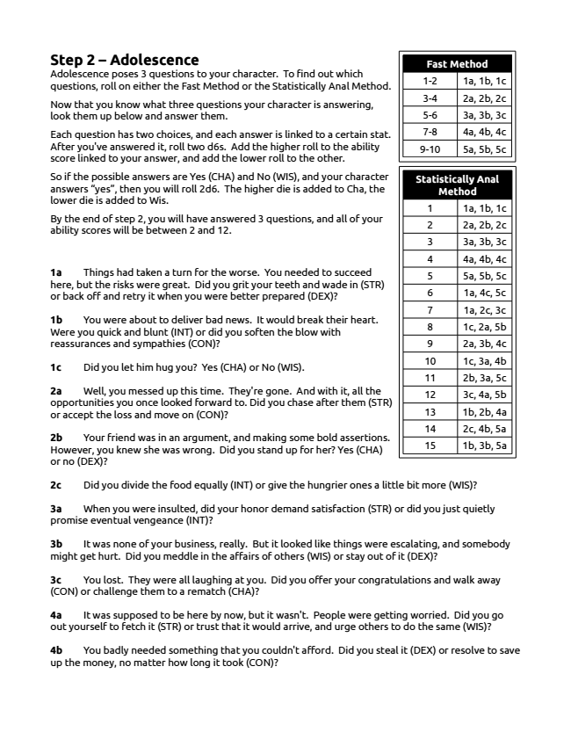
Step 2 – Adolescence Adolescence poses 3 questions to your character. To find out which questions, roll on either the Fast Method or the Statistically Anal Method.
Now that you know what three questions your character is answering, look them up below and answer them.
Each question has two choices, and each answer is linked to a certain stat. After you've answered it, roll two d6s. Add the higher roll to the ability score linked to your answer, and add the lower roll to the other.
So if the possible answers are Yes (CHA) and No (WIS), and your character answers “yes”, then you will roll 2d6. The higher die is added to Cha, the lower die is added to Wis.
By the end of step 2, you will have answered 3 questions, and all of your ability scores will be between 2 and 12.
1a Things had taken a turn for the worse. You needed to succeed here, but the risks were great. Did you grit your teeth and wade in (STR) or back off and retry it when you were better prepared (DEX)?
1b You were about to deliver bad news. It would break their heart. Were you quick and blunt (INT) or did you soften the blow with reassurances and sympathies (CON)?
1c Did you let him hug you? Yes (CHA) or No (WIS).
2a Well, you messed up this time. They're gone. And with it, all the opportunities you once looked forward to. Did you chase after them (STR) or accept the loss and move on (CON)?
2b Your friend was in an argument, and making some bold assertions. However, you knew she was wrong. Did you stand up for her? Yes (CHA) or no (DEX)?
2c Did you divide the food equally (INT) or give the hungrier ones a little bit more (WIS)?
3a When you were insulted, did your honor demand satisfaction (STR) or did you just quietly promise eventual vengeance (INT)?
3b It was none of your business, really. But it looked like things were escalating, and somebody might get hurt. Did you meddle in the affairs of others (WIS) or stay out of it (DEX)?
3c You lost. They were all laughing at you. Did you offer your congratulations and walk away (CON) or challenge them to a rematch (CHA)?
4a It was supposed to be here by now, but it wasn't. People were getting worried. Did you go out yourself to fetch it (STR) or trust that it would arrive, and urge others to do the same (WIS)?
4b You badly needed something that you couldn't afford. Did you steal it (DEX) or resolve to save up the money, no matter how long it took (CON)?
Fast Method
1-2 1a, 1b, 1c
3-4 2a, 2b, 2c 5-6 3a, 3b, 3c
7-8 4a, 4b, 4c
9-10 5a, 5b, 5c
Statistically Anal Method
1 1a, 1b, 1c
2 2a, 2b, 2c
3 3a, 3b, 3c
4 4a, 4b, 4c
5 5a, 5b, 5c 6 1a, 4c, 5c
7 1a, 2c, 3c
8 1c, 2a, 5b
9 2a, 3b, 4c
10 1c, 3a, 4b
11 2b, 3a, 5c 12 3c, 4a, 5b
13 1b, 2b, 4a
14 2c, 4b, 5a
15 1b, 3b, 5a
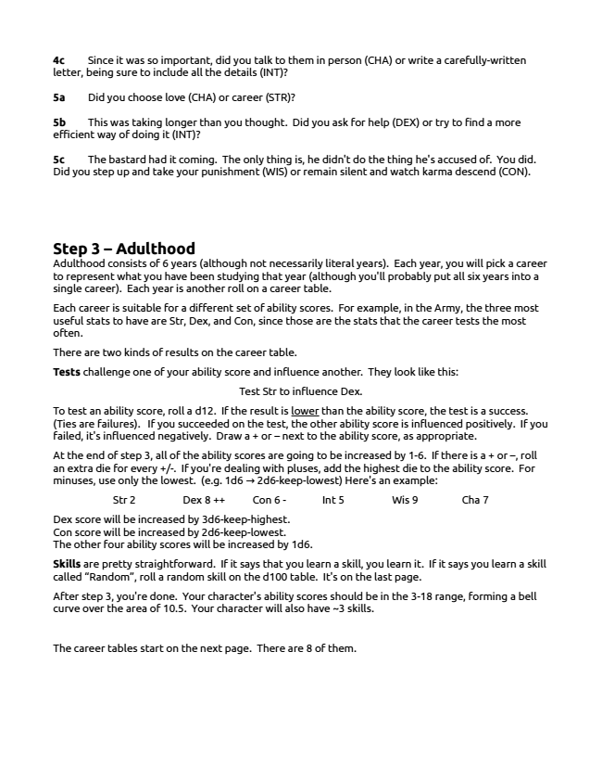
4c Since it was so important, did you talk to them in person (CHA) or write a carefully-written letter, being sure to include all the details (INT)?
5a Did you choose love (CHA) or career (STR)?
5b This was taking longer than you thought. Did you ask for help (DEX) or try to find a more efficient way of doing it (INT)?
5c The bastard had it coming. The only thing is, he didn't do the thing he's accused of. You did. Did you step up and take your punishment (WIS) or remain silent and watch karma descend (CON).
Step 3 – Adulthood Adulthood consists of 6 years (although not necessarily literal years). Each year, you will pick a career to represent what you have been studying that year (although you'll probably put all six years into a single career). Each year is another roll on a career table.
Each career is suitable for a different set of ability scores. For example, in the Army, the three most useful stats to have are Str, Dex, and Con, since those are the stats that the career tests the most often.
There are two kinds of results on the career table.
Tests challenge one of your ability score and influence another. They look like this:
Test Str to influence Dex.
To test an ability score, roll a d12. If the result is lower than the ability score, the test is a success. (Ties are failures). If you succeeded on the test, the other ability score is influenced positively. If you failed, it's influenced negatively. Draw a + or – next to the ability score, as appropriate.
At the end of step 3, all of the ability scores are going to be increased by 1-6. If there is a + or –, roll an extra die for every +/-. If you're dealing with pluses, add the highest die to the ability score. For minuses, use only the lowest. (e.g. 1d6 2d6-keep-lowest) Here's an example: →
Str 2 Dex 8 ++ Con 6 - Int 5 Wis 9 Cha 7
Dex score will be increased by 3d6-keep-highest. Con score will be increased by 2d6-keep-lowest. The other four ability scores will be increased by 1d6.
Skills are pretty straightforward. If it says that you learn a skill, you learn it. If it says you learn a skill called “Random”, roll a random skill on the d100 table. It's on the last page.
After step 3, you're done. Your character's ability scores should be in the 3-18 range, forming a bell curve over the area of 10.5. Your character will also have ~3 skills.
The career tables start on the next page. There are 8 of them.
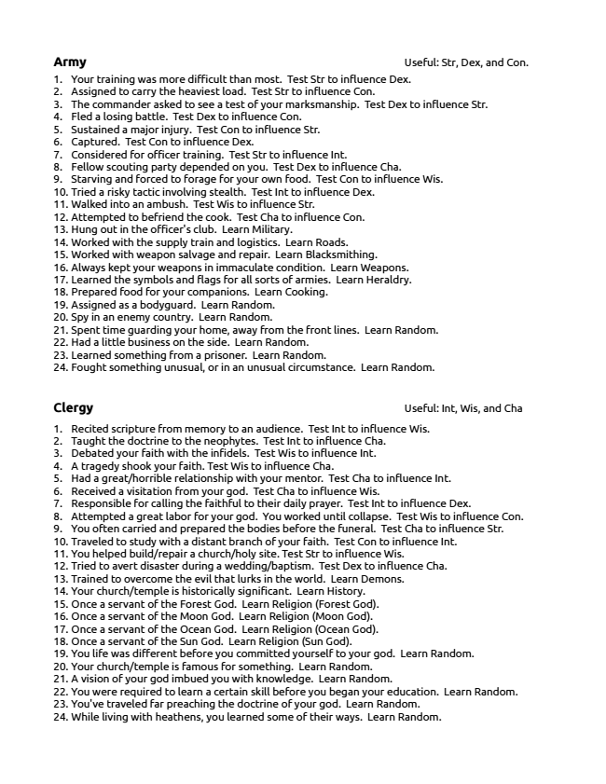
Army Useful: Str, Dex, and Con. 1. Your training was more difficult than most. Test Str to influence Dex. 2. Assigned to carry the heaviest load. Test Str to influence Con. 3. The commander asked to see a test of your marksmanship. Test Dex to influence Str. 4. Fled a losing battle. Test Dex to influence Con. 5. Sustained a major injury. Test Con to influence Str. 6. Captured. Test Con to influence Dex. 7. Considered for officer training. Test Str to influence Int. 8. Fellow scouting party depended on you. Test Dex to influence Cha. 9. Starving and forced to forage for your own food. Test Con to influence Wis. 10. Tried a risky tactic involving stealth. Test Int to influence Dex. 11. Walked into an ambush. Test Wis to influence Str. 12. Attempted to befriend the cook. Test Cha to influence Con. 13. Hung out in the officer's club. Learn Military. 14. Worked with the supply train and logistics. Learn Roads. 15. Worked with weapon salvage and repair. Learn Blacksmithing. 16. Always kept your weapons in immaculate condition. Learn Weapons. 17. Learned the symbols and flags for all sorts of armies. Learn Heraldry. 18. Prepared food for your companions. Learn Cooking. 19. Assigned as a bodyguard. Learn Random. 20. Spy in an enemy country. Learn Random. 21. Spent time guarding your home, away from the front lines. Learn Random. 22. Had a little business on the side. Learn Random. 23. Learned something from a prisoner. Learn Random. 24. Fought something unusual, or in an unusual circumstance. Learn Random.
Clergy Useful: Int, Wis, and Cha
1. Recited scripture from memory to an audience. Test Int to influence Wis. 2. Taught the doctrine to the neophytes. Test Int to influence Cha. 3. Debated your faith with the infidels. Test Wis to influence Int. 4. A tragedy shook your faith. Test Wis to influence Cha. 5. Had a great/horrible relationship with your mentor. Test Cha to influence Int. 6. Received a visitation from your god. Test Cha to influence Wis. 7. Responsible for calling the faithful to their daily prayer. Test Int to influence Dex. 8. Attempted a great labor for your god. You worked until collapse. Test Wis to influence Con. 9. You often carried and prepared the bodies before the funeral. Test Cha to influence Str. 10. Traveled to study with a distant branch of your faith. Test Con to influence Int. 11. You helped build/repair a church/holy site. Test Str to influence Wis. 12. Tried to avert disaster during a wedding/baptism. Test Dex to influence Cha. 13. Trained to overcome the evil that lurks in the world. Learn Demons. 14. Your church/temple is historically significant. Learn History. 15. Once a servant of the Forest God. Learn Religion (Forest God). 16. Once a servant of the Moon God. Learn Religion (Moon God). 17. Once a servant of the Ocean God. Learn Religion (Ocean God). 18. Once a servant of the Sun God. Learn Religion (Sun God). 19. You life was different before you committed yourself to your god. Learn Random. 20. Your church/temple is famous for something. Learn Random. 21. A vision of your god imbued you with knowledge. Learn Random. 22. You were required to learn a certain skill before you began your education. Learn Random. 23. You've traveled far preaching the doctrine of your god. Learn Random. 24. While living with heathens, you learned some of their ways. Learn Random.
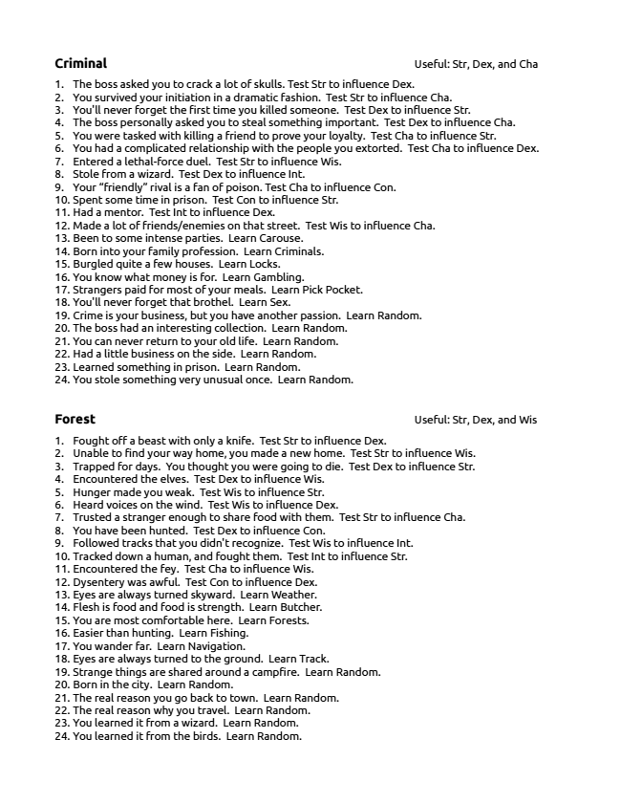
Criminal Useful: Str, Dex, and Cha
1. The boss asked you to crack a lot of skulls. Test Str to influence Dex. 2. You survived your initiation in a dramatic fashion. Test Str to influence Cha. 3. You'll never forget the first time you killed someone. Test Dex to influence Str. 4. The boss personally asked you to steal something important. Test Dex to influence Cha. 5. You were tasked with killing a friend to prove your loyalty. Test Cha to influence Str. 6. You had a complicated relationship with the people you extorted. Test Cha to influence Dex. 7. Entered a lethal-force duel. Test Str to influence Wis. 8. Stole from a wizard. Test Dex to influence Int. 9. Your “friendly” rival is a fan of poison. Test Cha to influence Con. 10. Spent some time in prison. Test Con to influence Str. 11. Had a mentor. Test Int to influence Dex. 12. Made a lot of friends/enemies on that street. Test Wis to influence Cha. 13. Been to some intense parties. Learn Carouse. 14. Born into your family profession. Learn Criminals. 15. Burgled quite a few houses. Learn Locks. 16. You know what money is for. Learn Gambling. 17. Strangers paid for most of your meals. Learn Pick Pocket. 18. You'll never forget that brothel. Learn Sex. 19. Crime is your business, but you have another passion. Learn Random. 20. The boss had an interesting collection. Learn Random. 21. You can never return to your old life. Learn Random. 22. Had a little business on the side. Learn Random. 23. Learned something in prison. Learn Random. 24. You stole something very unusual once. Learn Random.
Forest Useful: Str, Dex, and Wis
1. Fought off a beast with only a knife. Test Str to influence Dex. 2. Unable to find your way home, you made a new home. Test Str to influence Wis. 3. Trapped for days. You thought you were going to die. Test Dex to influence Str. 4. Encountered the elves. Test Dex to influence Wis. 5. Hunger made you weak. Test Wis to influence Str. 6. Heard voices on the wind. Test Wis to influence Dex. 7. Trusted a stranger enough to share food with them. Test Str to influence Cha. 8. You have been hunted. Test Dex to influence Con. 9. Followed tracks that you didn't recognize. Test Wis to influence Int. 10. Tracked down a human, and fought them. Test Int to influence Str. 11. Encountered the fey. Test Cha to influence Wis. 12. Dysentery was awful. Test Con to influence Dex. 13. Eyes are always turned skyward. Learn Weather. 14. Flesh is food and food is strength. Learn Butcher. 15. You are most comfortable here. Learn Forests. 16. Easier than hunting. Learn Fishing. 17. You wander far. Learn Navigation. 18. Eyes are always turned to the ground. Learn Track. 19. Strange things are shared around a campfire. Learn Random. 20. Born in the city. Learn Random. 21. The real reason you go back to town. Learn Random. 22. The real reason why you travel. Learn Random. 23. You learned it from a wizard. Learn Random. 24. You learned it from the birds. Learn Random.
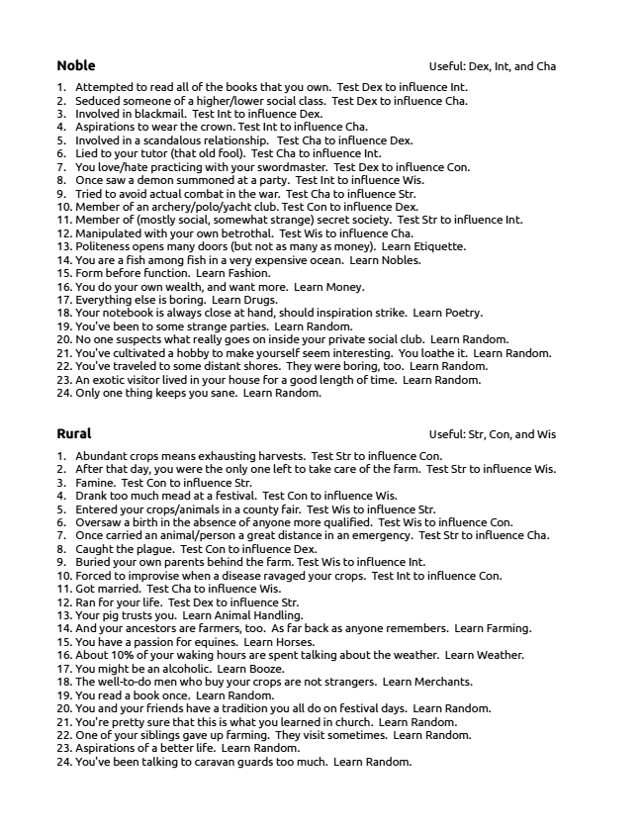
Noble Useful: Dex, Int, and Cha
1. Attempted to read all of the books that you own. Test Dex to influence Int. 2. Seduced someone of a higher/lower social class. Test Dex to influence Cha. 3. Involved in blackmail. Test Int to influence Dex. 4. Aspirations to wear the crown. Test Int to influence Cha. 5. Involved in a scandalous relationship. Test Cha to influence Dex. 6. Lied to your tutor (that old fool). Test Cha to influence Int. 7. You love/hate practicing with your swordmaster. Test Dex to influence Con. 8. Once saw a demon summoned at a party. Test Int to influence Wis. 9. Tried to avoid actual combat in the war. Test Cha to influence Str. 10. Member of an archery/polo/yacht club. Test Con to influence Dex. 11. Member of (mostly social, somewhat strange) secret society. Test Str to influence Int. 12. Manipulated with your own betrothal. Test Wis to influence Cha. 13. Politeness opens many doors (but not as many as money). Learn Etiquette. 14. You are a fish among fish in a very expensive ocean. Learn Nobles. 15. Form before function. Learn Fashion. 16. You do your own wealth, and want more. Learn Money. 17. Everything else is boring. Learn Drugs. 18. Your notebook is always close at hand, should inspiration strike. Learn Poetry. 19. You've been to some strange parties. Learn Random. 20. No one suspects what really goes on inside your private social club. Learn Random. 21. You've cultivated a hobby to make yourself seem interesting. You loathe it. Learn Random. 22. You've traveled to some distant shores. They were boring, too. Learn Random. 23. An exotic visitor lived in your house for a good length of time. Learn Random. 24. Only one thing keeps you sane. Learn Random.
Rural Useful: Str, Con, and Wis
1. Abundant crops means exhausting harvests. Test Str to influence Con. 2. After that day, you were the only one left to take care of the farm. Test Str to influence Wis. 3. Famine. Test Con to influence Str. 4. Drank too much mead at a festival. Test Con to influence Wis. 5. Entered your crops/animals in a county fair. Test Wis to influence Str. 6. Oversaw a birth in the absence of anyone more qualified. Test Wis to influence Con. 7. Once carried an animal/person a great distance in an emergency. Test Str to influence Cha. 8. Caught the plague. Test Con to influence Dex. 9. Buried your own parents behind the farm. Test Wis to influence Int. 10. Forced to improvise when a disease ravaged your crops. Test Int to influence Con. 11. Got married. Test Cha to influence Wis. 12. Ran for your life. Test Dex to influence Str. 13. Your pig trusts you. Learn Animal Handling. 14. And your ancestors are farmers, too. As far back as anyone remembers. Learn Farming. 15. You have a passion for equines. Learn Horses. 16. About 10% of your waking hours are spent talking about the weather. Learn Weather. 17. You might be an alcoholic. Learn Booze. 18. The well-to-do men who buy your crops are not strangers. Learn Merchants. 19. You read a book once. Learn Random. 20. You and your friends have a tradition you all do on festival days. Learn Random. 21. You're pretty sure that this is what you learned in church. Learn Random. 22. One of your siblings gave up farming. They visit sometimes. Learn Random. 23. Aspirations of a better life. Learn Random. 24. You've been talking to caravan guards too much. Learn Random.
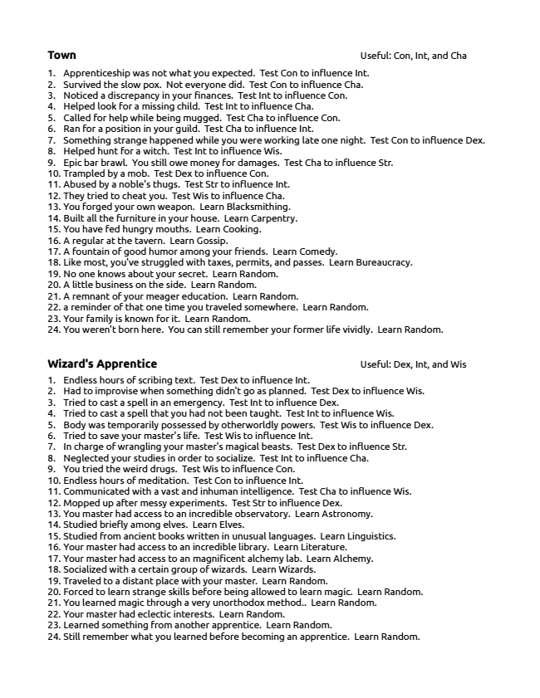
Town Useful: Con, Int, and Cha
1. Apprenticeship was not what you expected. Test Con to influence Int. 2. Survived the slow pox. Not everyone did. Test Con to influence Cha. 3. Noticed a discrepancy in your finances. Test Int to influence Con. 4. Helped look for a missing child. Test Int to influence Cha. 5. Called for help while being mugged. Test Cha to influence Con. 6. Ran for a position in your guild. Test Cha to influence Int. 7. Something strange happened while you were working late one night. Test Con to influence Dex. 8. Helped hunt for a witch. Test Int to influence Wis. 9. Epic bar brawl. You still owe money for damages. Test Cha to influence Str. 10. Trampled by a mob. Test Dex to influence Con. 11. Abused by a noble's thugs. Test Str to influence Int. 12. They tried to cheat you. Test Wis to influence Cha. 13. You forged your own weapon. Learn Blacksmithing. 14. Built all the furniture in your house. Learn Carpentry. 15. You have fed hungry mouths. Learn Cooking. 16. A regular at the tavern. Learn Gossip. 17. A fountain of good humor among your friends. Learn Comedy. 18. Like most, you've struggled with taxes, permits, and passes. Learn Bureaucracy. 19. No one knows about your secret. Learn Random. 20. A little business on the side. Learn Random. 21. A remnant of your meager education. Learn Random. 22. a reminder of that one time you traveled somewhere. Learn Random. 23. Your family is known for it. Learn Random. 24. You weren't born here. You can still remember your former life vividly. Learn Random.
Wizard's Apprentice Useful: Dex, Int, and Wis 1. Endless hours of scribing text. Test Dex to influence Int. 2. Had to improvise when something didn't go as planned. Test Dex to influence Wis. 3. Tried to cast a spell in an emergency. Test Int to influence Dex. 4. Tried to cast a spell that you had not been taught. Test Int to influence Wis. 5. Body was temporarily possessed by otherworldly powers. Test Wis to influence Dex. 6. Tried to save your master's life. Test Wis to influence Int. 7. In charge of wrangling your master's magical beasts. Test Dex to influence Str. 8. Neglected your studies in order to socialize. Test Int to influence Cha. 9. You tried the weird drugs. Test Wis to influence Con. 10. Endless hours of meditation. Test Con to influence Int. 11. Communicated with a vast and inhuman intelligence. Test Cha to influence Wis. 12. Mopped up after messy experiments. Test Str to influence Dex. 13. You master had access to an incredible observatory. Learn Astronomy. 14. Studied briefly among elves. Learn Elves. 15. Studied from ancient books written in unusual languages. Learn Linguistics. 16. Your master had access to an incredible library. Learn Literature. 17. Your master had access to an magnificent alchemy lab. Learn Alchemy. 18. Socialized with a certain group of wizards. Learn Wizards. 19. Traveled to a distant place with your master. Learn Random. 20. Forced to learn strange skills before being allowed to learn magic. Learn Random. 21. You learned magic through a very unorthodox method.. Learn Random. 22. Your master had eclectic interests. Learn Random. 23. Learned something from another apprentice. Learn Random. 24. Still remember what you learned before becoming an apprentice. Learn Random.
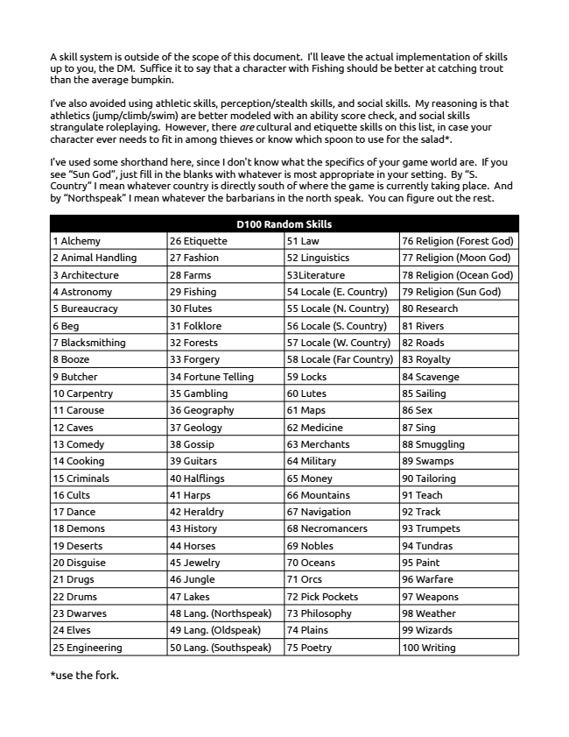
A skill system is outside of the scope of this document. I'll leave the actual implementation of skills up to you, the DM. Suffice it to say that a character with Fishing should be better at catching trout than the average bumpkin.
I've also avoided using athletic skills, perception/stealth skills, and social skills. My reasoning is that athletics (jump/climb/swim) are better modeled with an ability score check, and social skills strangulate roleplaying. However, there are cultural and etiquette skills on this list, in case your character ever needs to fit in among thieves or know which spoon to use for the salad*.
I've used some shorthand here, since I don't know what the specifics of your game world are. If you see “Sun God”, just fill in the blanks with whatever is most appropriate in your setting. By “S. Country” I mean whatever country is directly south of where the game is currently taking place. And by “Northspeak” I mean whatever the barbarians in the north speak. You can figure out the rest.
D100 Random Skills
1 Alchemy 26 Etiquette 51 Law 76 Religion (Forest God)
2 Animal Handling 27 Fashion 52 Linguistics 77 Religion (Moon God) 3 Architecture 28 Farms 53Literature 78 Religion (Ocean God)
4 Astronomy 29 Fishing 54 Locale (E. Country) 79 Religion (Sun God)
5 Bureaucracy 30 Flutes 55 Locale (N. Country) 80 Research
6 Beg 31 Folklore 56 Locale (S. Country) 81 Rivers
7 Blacksmithing 32 Forests 57 Locale (W. Country) 82 Roads
8 Booze 33 Forgery 58 Locale (Far Country) 83 Royalty 9 Butcher 34 Fortune Telling 59 Locks 84 Scavenge
10 Carpentry 35 Gambling 60 Lutes 85 Sailing
11 Carouse 36 Geography 61 Maps 86 Sex
12 Caves 37 Geology 62 Medicine 87 Sing
13 Comedy 38 Gossip 63 Merchants 88 Smuggling
14 Cooking 39 Guitars 64 Military 89 Swamps 15 Criminals 40 Halflings 65 Money 90 Tailoring
16 Cults 41 Harps 66 Mountains 91 Teach
17 Dance 42 Heraldry 67 Navigation 92 Track
18 Demons 43 History 68 Necromancers 93 Trumpets
19 Deserts 44 Horses 69 Nobles 94 Tundras
20 Disguise 45 Jewelry 70 Oceans 95 Paint 21 Drugs 46 Jungle 71 Orcs 96 Warfare
22 Drums 47 Lakes 72 Pick Pockets 97 Weapons
23 Dwarves 48 Lang. (Northspeak) 73 Philosophy 98 Weather
24 Elves 49 Lang. (Oldspeak) 74 Plains 99 Wizards
25 Engineering 50 Lang. (Southspeak) 75 Poetry 100 Writing
*use the fork.

