Eldeth Brawnanvil - backstory & questions

Where is she from, and how did she end up in Neverwinter?

She is from Mintarn, an island nation known for poilitical neutrality, for its mercenary companies serving (until recently) in Waterdeep and Neverwinter, and for being dominated by a red dragon demanding regular tribute.
Mintarn had become prosperous due to lucrative mercenary contracts with the cities of Waterdeep and Neverwinter. Dagult Neverember, during his time as Open Lord of Waterdeep and later as Lord Protector of Neverwinter, invested heavily in the island, starting a large sailing and mercenary company called White Sails. More recently, the Mintarn mercenaries were dismisssed from their contracts in Waterdeep in favor of local militias, and they are being phased out of their role in Neverwinter as well. The red dragon, noticing the prosperity of Mintarn, had increased its tribute demands, and the loss of the mercenary contracts has created economic depression, putting the island nation in a hard spot. Lord Protector Neverember has divested from the White Sails company and his interests in Mintarn, and has been reducing the mercenary contracts in Neverwinter, so he is seen by the Mintarnese as having abandoned the island in its time of need.
Eldeth had been serving in a mercenary company in Neverwinter, but she was recently dismissed for refusing to obey an order that violated her conscience.

What was the order she refused to obey, and is this somehow related to her calling to serve the goddess Sharindlar, dwarven goddess of healing?

Maybe she was ordered to kill someone who should have been taken prisoner, or to let a captive suffer and die rather than treating their wounds. Her devotion to the goddess of healing should be an important part of her character.
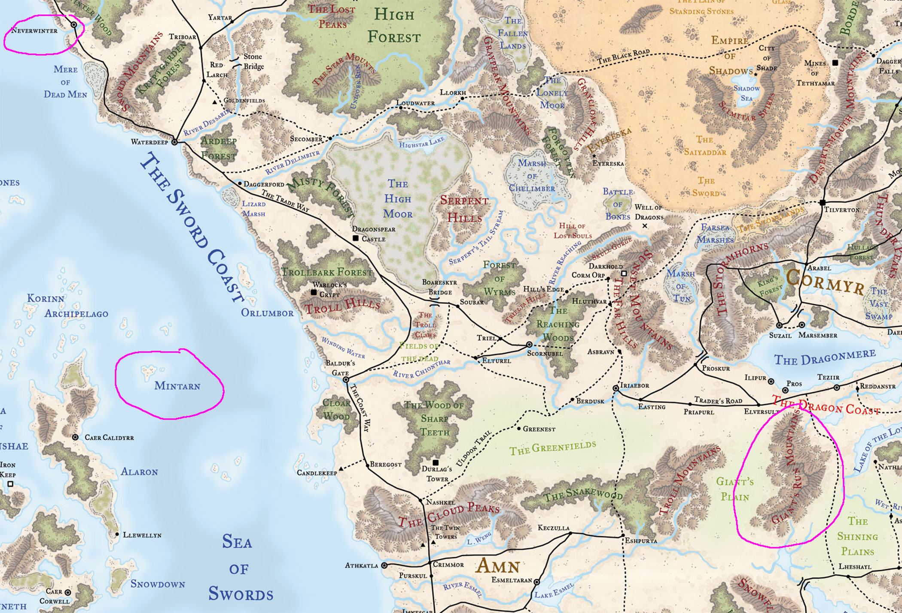
Was she born on Mintarn, or how did she come there?

My thought was that she might be from a gold dwarf settlement in the foothills of the Giant’s Run Mountains. These mountains were the site of a historic battle between dwarves and giants thousands of years ago. Several hundred years ago, an undead stone giant sorcerer established the underground stronghold of Cairnhelm under the mountains, and united the scattered stone giant clans who had fled into the Underdark after their defeat by the dwarves. Occasionally, dwarven mine tunnels accidentally breach the Underdark, with disastrous results. Perhaps Eldeth’s clan had been operating a mine, accidentally opened a tunnel into the underground sone giants’ stronghold or some other part of the Underdark, and the mine and most of the clan were subsequently destroyed.
Also, about 100 years before the present time, a network of evil undead mages established a portal in the Giant’s Run Mountains, which they could to travel to other portals they had built throughout the realms. The current status of the organization is unknown, but the portal is a way for all undead creatures to enter the mountains and could be another reason the area became inhospitable for Eldeth and her people.

If she wasn’t born on Mintarn, why did she travel there? Did she go there alone, or with other members of her clan? Does she still have family there?

During its period of increasing prosperity, Mintarn would have had work opportunities for dwarven craftspeople, forging weapons and crafting jewelry. Perhaps Eldeth’s surviving clan members were drawn to the island for that reason. Dragons crave treasure but have no real use for it; perhaps the dragon of Mintarn had grown bored with regular wealth and demanded ever-more-intricate treasures for its tribute, requiring the skill of dwarven craftspeople to create.

Why did Eldeth become a mercenary soldier?

When and how did she begin to experience a calling to serve Sharindlar?

How is her calling to serve the goddess related to her clan’s history, what she or they experienced in the Giant’s Run Mountains, and/or what she experienced in Mintarn?

What role does the red dragon play in her story?

Does she still have surviving clan members in Mintarn, and what role does this play in her motivations as an adventurer on the mainland?

Does she want to free her clan from the tyranny of the dragon once she becomes powerful enough to challenge it? Or is she the lone surviving member of her clan, having traveled to Mintarn alone with what gems she was able to salvage from her clan’s destroyed mine?

How old is Eldeth? (average dwarf lifespan ~400 years)

